V. MASS CULTURE OF RHIZOBIA

A. Media for Fermentors

Rhizobia are moderately easy to culture and not particularly fastidious in their nutrient requirements. Nearly all rhizobia utilize monosaccharides and disaccharides readily and to a lesser extent trisaccharides, alcohols and acids. Starch is not utilized. The soybean and cowpea type rhizobia prefer pentoses such as arabinose or xylose. Sucrose and mannitol are probably the most commonly used energy sources. According to Graham and Parker (1964), Rhizobium strains within a species can differ in their ability to utilize carbohydrates. Consequently, it is important to make certain the Rhizobium strains selected can utilize the carbohydrate in the fermentor medium.

Yeast and plant extracts such as alfalfa, cabbage and peas, as well as casein and corn steep liquids are considered beneficial to growth of rhizobia. These extracts and hydrolysates can also provide carbohydrates for growth of rhizobia. This could mask the need for growth factors, micronutrients, and specific carbon sources, particularly when a generous amount of the extract is added. Yeast extract is the most commonly used growth factor supplement for rhizobia. Other suitable substitutes are listed in Appendix A.

The composition of some media which have been used successfully in culturing rhizobia is given in Table 3. Two of the media contain mannitol only, one contains sucrose only and another contains both sucrose and mannitol as a carbon source. The author has found that a small amount of lactic acid stimulates growth particularly of the slow-growing rhizobia. The lactic acid solution is used as a solvent for micronutrients, cobalt molybdenum, zinc, copper, iron and boron which are considered essential for N fixation by the legume but may not be required for growth of rhizobia (Table 2).
Table 2. Micronutrient - Stock Solution - Burton

Ingredient | Per liter
Boric Acid, H₃BO₃ | 2.780 g
Manganese sulphate, MnSO₄.7H₂O | 1.540 g
Zinc sulphate, ZnSO₄.7H₂O | 0.210 g
Sodium molybdate, Na₂MoO₄ | 4.360 g
Ferric chloride, FeCl₃.6H₂O | 5.000 g
Cobalt sulphate | 0.004 g
Lactic acid (88%) | 580.0 ml
Distilled water | 420.0 ml

* Addition of 1.0 ml per liter of medium gives: boron 0.5 microgram; manganese 0.5 microgram; zinc 0.05 microgram; molybdenum 1.0 microgram; iron 100 micrograms and cobalt 0.0005 microgram per liter or part per million (p.p.m.)
Table 3. Composition of Media for Growth of Rhizobia
Ingredient | Fred and Waksman  1928 | VanSchreven  1963 | Date 1976 | Burton 1967
 | -------------------grams per liter-------------------
Mannitol | 10.0 | ─ | 10.0 | 2.0
Sucrose | ─ | 15.0 | ─ | 10.0
Dipotassium phosphate  (K₂HPO₄) | 0.5 | 0.5 | 0.5 | ─
Tripotassium phosphate  (K₃PO₄) | ─ | ─ | ─ | 0.2
Monopotassium phosphate  (KH₂PO₄) | ─ | ─ | ─ | 0.4
Magnesium sulphate  (MgSO₄.7H₂O) | 0.2 | 0.2 | 0.2 | 0.2
Sodium chloride  (NaCl) | 0.1 | ─ | 0.2 | 0.06
Calcium carbonate  (CaCO₃) | 3.0 | 2.0 | ─ | 0.2
Calcium sulphate  (CaSO₄.2H₂O) | ─ | ─ | ─ | 0.04
Iron chloride  (FeCl₃.6H₂O) | ─ | ─ | 0.1 | ─
Yeast water | 100.0 ml | 100.0 ml | 100.0 ml | ─
Yeast extract | ─ | ─ | ─ | 0.5
Paraffin oil | ─ | 0.5 | ─ | ─
Ammonium phosphate  (NH₄)₂ HPO | ─ | ─ | ─ | 0.1
Water | 900 ml | 900 ml | 900.0 ml | 1,000 ml
Micronutrient Solution* | ─ | ─ | ─ | 0.3

* See special nutrient solution - Burton, Table 2
B. Preparation of Yeast Water

Fresh starch-free cakes of yeast are preferred in making yeast water. Suspend 100 g of yeast in 1,000 ml of water and boil slowly or steam for 3 to 4 hours, replacing the water lost regularly. Allow the cooked suspension to stand until yeast cells have settled to the bottom, usually 10 to 12 hours. Siphon off the clear, straw-colored liquid; adjust the liquid to pH 6.6 to 6.8 with sodium hydroxide; bottle and autoclave for 30 to 40 minutes at 121°C. Following sterilization, the yeast water may be stored at room temperature.

Dried yeast may also be used in making yeast water. One pound of dry yeast is equal to about 2.5 lbs of wet yeast. Suspend 40 g of dry yeast in liter of water. Boil, decant, bottle and Sterilize in the same way as described for fresh yeast. One hundred milliliters of yeast water should contain about 75 mg of nitrogen.

Yeast extract powders prepared by spray-drying aqueous autolyzed yeast preparations are available in many countries. When these are available, about 0.5 g of the dried preparation per liter is used to replace yeast water. Dry preparations are convenient and usually satisfactory.

The media containing yeast described above may foam excessively when aerated vigorously in fermentor vessels. Foaming can be controlled by adding a small amount of sterile white mineral oil or silicone emulsion.

C. Culture Vessels

Rhizobia are relatively easy to grow and the medium is a simple one. Methods of culturing rhizobia vary with manufacturers, but aeration of the medium with sterile compressed air is the most common. Mechanical agitation may be used; its usefulness is primarily to expedite heat exchange during sterilization and cooling of the liquid medium. Mechanical agitation is not needed or recommended for small fermentors. Agitators are expensive and the shaft bearing can be a source of contamination.

Growth is not increased by violent aeration or agitation. An oxygen partial pressure of 0.15 atmosphere is optimum for respiration. The low oxygen requirement of rhizobia is undoubtedly associated with the organism's ability to grow in the interior of an active nodule where a low oxygen tension prevails. A temperature of 28 to 30°C is optimum for growth of rhizobia.

The fermentor for culture of rhizobia should have a simple design with the following specifications (Figure 1).

1. Ability to withstand internal pressure of 30 psi steam or greater.
2. Handy access port to facilitate adding medium and washing, and closure which provides a dependable seal during and following sterilization.
3. Metal such as stainless steel which is nontoxic to bacteria and easy to clean. Types 304 or 316 stainless steel may be used.
4. Ability to withstand direct heating with a gas or oil flame for easy sterilization.
5. Equipped to supply sterile air through a sparger to aerate the broth medium and provide oxygen for the rhizobia.
6. Inoculum port for adding the starter aseptically.
7. Sample port which is easy to sterilize to facilitate monitoring of the growth and purity of the culture.
8. Air exhaust tube with valve for regulation of aeration.
9. Fermentor should be equipped with an accurate, rugged thermometer of the bimetallic type, a pressure gauge, and a pop safety valve.
10. Strength and durability to withstand handling and use over a long period of time.
11. Permit aseptic removal of the broth culture and easy cleaning.
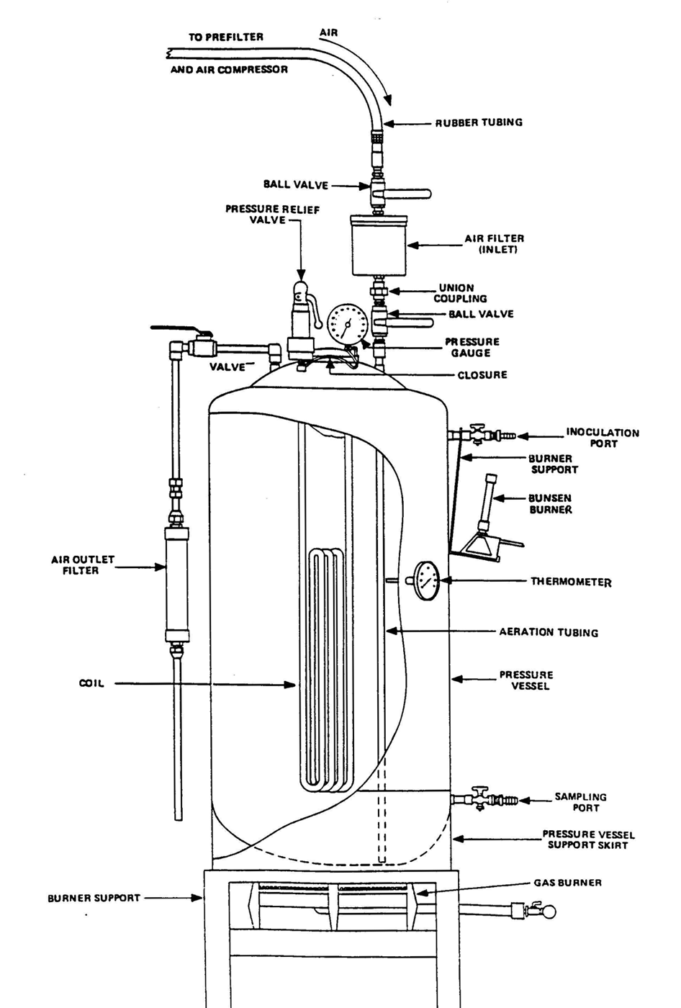

Figure 1. FERMENTOR

D. Fermentor Requirements for Various Production Goals

Production of legume inoculants begins with cultures grown in test tubes. The rhizobia grown in tubes are transferred to larger vessels, Roux bottles or Erlenmeyer flasks for shake culture. The rhizobia grown in Roux bottles or shake flasks are transferred to small or large fermentors based on needs. The various stages in inoculant production are shown in Figure 2. Each step in culturing rhizobia requires 48 to 72 hours and should bring about a 20 to 100-fold increase in volume of usable broth culture. A 3 to 5% larger starter is used with slow-growing rhizobia to offset their slower growth.

One of the first steps in preparing for legume inoculant production is to estimate as accurately as possible the kinds and amounts of various inoculants which will be needed each season of the year. In doing this, consideration must be given to the number of strains of Rhizobium which will be used in each inoculant and the leguminous crops to be inoculated. The equipment specified should allow flexibility and production of 130 to 150% of anticipated needs because for various reasons such as some unavoidable contamination the actual production will often be less than theoretical production. However, with well-designed equipment and good techniques, one can obtain 95 to 98% of theoretical production.

The data in Table 4 show the amounts of inoculant which can be produced and the area of land which can be planted to soybeans with various quantities of broth culture.

The data in Table 4 are based on the use of a pulverized sedge peat with an 8% moisture content as the carrier medium, the addition of 8 kg of CaCO³ to 92 kg of powdered peat, a moisture content of 40% in the finished inoculant, and an application rate of 5 g of inoculant to 1 kg of soybean seed. The potential inoculant production with various fermentor capacities during a 9 month production season and conversion factors for acreages of various other legumes are listed at the bottom of the table.

The volume of broth culture grown should not exceed that which can be mixed with the carrier processed and packaged when it reaches the proper stage. The fermentors should not be used or considered as storage vessels. Rhizobia soon lose their ability to grow and multiply in the carrier medium after they reach the stationary growth phase. Broth culture should be mixed with the carrier while the rhizobia are in the logarithmic growth phase.

The weight of inoculant which can be made with a given volume of broth culture is similar for all legumes but the volume of seed this will inoculate or the hectarage of land covered will vary widely with leguminous species, seed size, and rate of sowing (Table 5). With small-seeded legumes, larger quantities of inoculant are needed to provide sufficient viable Rhizobium cells to assure effective nodulation.
Figure 2. Single Strain Inoculant Production

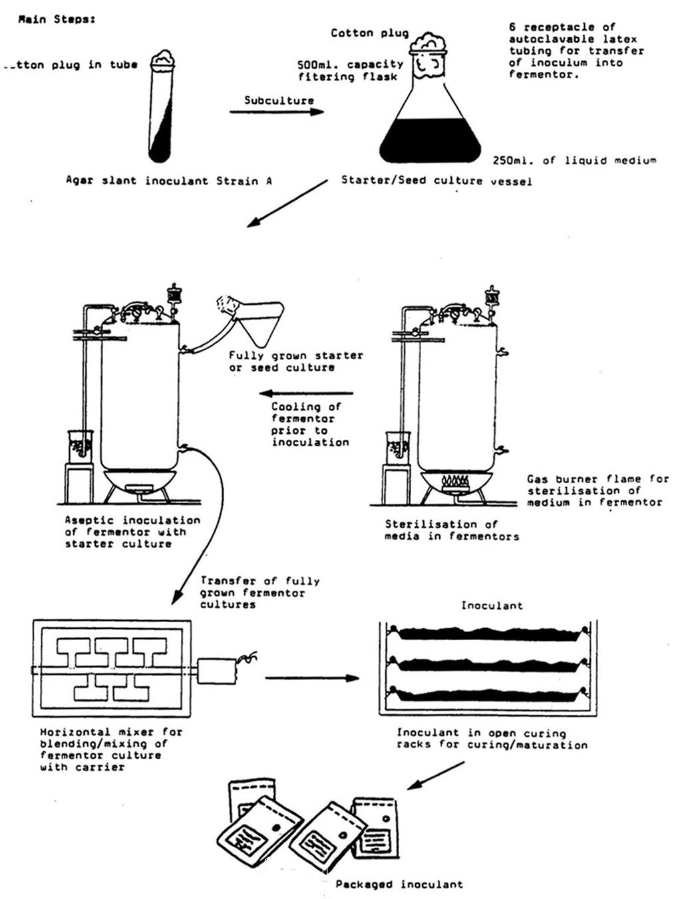
Table 4. Potential inoculant production with various sizes of fermentor

Fermentor Volume | Operating Capacity  75% volume | Weight of Inoculant/Batch Peat Base | Inoculant/9 months One batch per wk. 36 Batches | Enough for Soybeans hectares*
 | Liters | Kilogram | Kilogram
6 gal (22 L) | 17 | 47 | 1,692 | 5,206
16 gal (60 L) | 45 | 126 | 4.536 | 13,957
37 gal (140 L) | 106 | 297 | 10,692 | 32,898
50 gal (189 L) | 142 | 398 | 14,328 | 44,086
60 gal (227 L) | 170 | 476 | 17,135 | 52,726
75 gal (284 L) | 213 | 596 | 21,456 | 66,018
100 gal (378 L) | 284 | 795 | 28,620 | 88,062
*soybeans planted 65 kg/hectare; inoculant applied at rate of 5 g/kg seed.

Conversion factors for other legumes are:
Legume | Planting Rate | Conversion Factor
 | kg/ha
Lotonois bainesii | 2 | X 32.5
Medicago sativa | 16 | X 4.0
Vigna radiata | 76 | X 0.85
Vigna unguiculata | 80 | X 0.81
Cicer arietinum | 33 | X 1.97
Vicia faba | 87 | X 0.75

Table 5. Relation of legume seed size and rate of planting to area which can be sown with inoculum prepared from one liter of broth culture (3 kg peat-base inoculum).

Leguminous plant | Seeds/kg | Rhizobia/Seed  5g Inoc/kg seed | Seed/ha kg | Hectares  sown
Lotonois bainesii | 3,700,000 | 135 | 2 | 300.0
Medicago sativa | 500,000 | 1,000 | 16 | 37.5
Coronilla varia | 250,000 | 2,000 | 20 | 30.0
Vigna radiata | 25,000 | 20,000 | 76 | 7.9
Vigna unguiculata | 10,000 | 50,000 | 80 | 7.5
Glycine max | 5,000 | 100,000 | 65 | 9.2
Cicer arietinum | 2,000 | 250,000 | 33 | 18.2
Vicia faba | 1,250 | 400,000 | 87 | 6.9

In planning an inoculant production facility, it should be remembered that small culture vessels are always needed regardless of the production capacity required. The small fermentors are needed to grow seed or starter cultures for the larger fermentors as well as for inocula required in only small amounts. Further, with sufficient small fermentors, the production capacity can be greatly increased by acquiring one or more large fermentors for the final multiplication stage and by using a 5 to 10% starter.

Metal pressure vessels, which can be equipped for aeration with sterile air, are preferable to glass. Stainless steel is easier to keep clean than carbon steel. Vessels which can be heated directly by an open burner have advantages over those which have to be autoclaved.

